**Implementing Web Application**

**Integrate Rapid API**

|  |  |
| --- | --- |
| Team ID | PNT2022TMID18761 |
| Project Name | News Tracker Application |

**RAPID API:**

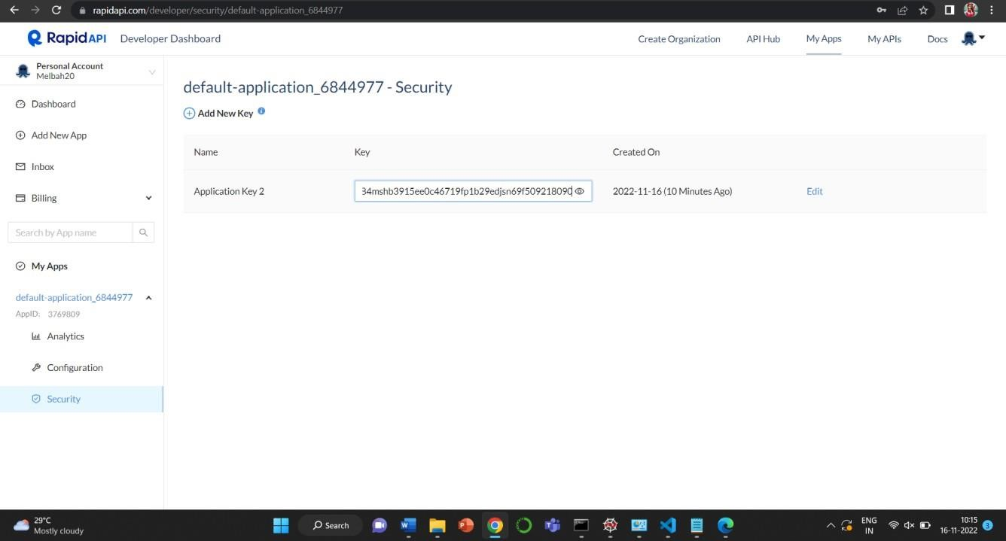

**Integrate rapid API:**

